Encapsulation
Encapsulation is one of the main pillars of OOP, it’s the bundling of data and methods that act on that data into a single unit, and this unit is called a class.
So, the class acts as a capsule that holds the attributes and the methods of the object, it separates them or kind of isolates them from the rest of the program because they are part of this larger unit called the class.
The purpose of the class or the purpose of this larger unit that contains these elements is to be able to restrict access to these elements following the principal of information hiding. This capsule that is made by the class serves as a shield because its goal is to prevent direct access to the attributes and to the data of the object in order to avoid making potentially problematic changes its state.
Abstraction
Abstraction is one of the basic pillars of OOP and it basically states that we should show only the essential attributes of a class or an object (only the essential members) and hide unnecessary details from the user of the class in this case.
This principle lets us hide the complexity of the internal implementation of the class from the user.
For example, having a real world analogy, when you see a smartphone, you use the graphical user interface that the developers created for you to interact with the phone like buttons and elements that let you use the phone in a user friendly way. You don’t need to understand all the complex details or steps that occur behind the scenes in this electronic device when you actually use your phone and this is an example of abstraction in the real world.
A class has two main parts: an interface and an implementation we can sort of divide the class into these two parts.
The interface is the “visible” part of the class that the program can interact with, it is basically what we choose to show from that capsule.
The implementation is the other part, the internal part of the class with the code that performs the functionality behind the scenes, it is the actual code that makes all the functionality of the class work.
Public and Non-Public Attributes
Public and non-public attributes play a key role in object oriented programming because they help us follow the principle of encapsulation by making some attributes public and others non-public, we can restrict the access to these elements and protect them from unexpected changes.
In Python, attributes can be either public or nonpublic.
A public attribute is an attribute that can be accessed and modified directly without any access restrictions, so we can access and modify it anywhere in our program.
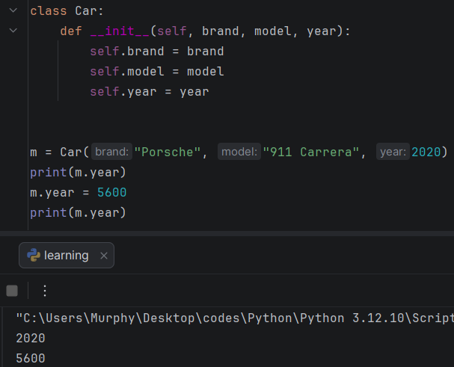
The risks of making an attribute public and completely accessible from anywhere in our program is defined by the picture above, let’s say somewhere in our code we write this line of code: m.year = 5600, we are actually updating the year of car to 5600 and that will cause a serious bug in the system and if we print them we can see that the year is changed from 2020 to 5600, that’s one of the risks of making an attribute completely public that we can access it and modify it directly outside of class without any validation.
A Non-public attribute is an attribute that shouldn’t be accessed or modified outside of the class. In python we’ve two ways of defining a Non-Public attribute by naming convention or by activating a mechanism that changes the attributes name and makes it more difficult to access and it’s called Name Mangling. When we use the naming convention which is what we typically do, we just add a leading underscore ( _ ) to the name of the attribute and this will immediately tell other developers visually thar the attribute that the attribute should be treated as a Non-Public, so it shouldn’t be accessed or modified directly outside of the class.
We can also trigger this process of Name Mangling of changing the name by adding two underscores ( __ ) two leading underscores to the name of the attribute, this makes it more difficult for developers to access the name because we’re actually changing the name during the process.
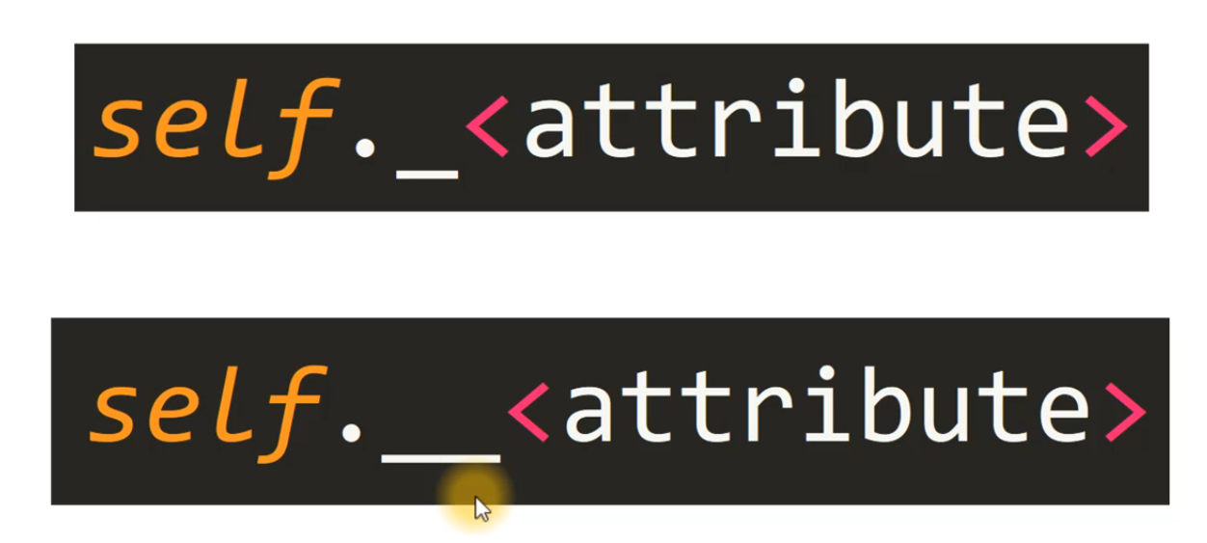
Remember:
One leading underscore ( _ ) is a naming convention. And two leading underscores ( __ )triggers process of name Mangling and should only be used for special cases.

Name Mangling
Since there is a valid use-case for class-private members (namely to avoid clashes of names with names defined by subclasses), there is a limited support for such a mechanism, called Name Mangling. Any identifier of the form __spam (at least two leading underscores) is textually replaced with _classname__spam, where classname is the current class name with leading underscore(s) stripped. Example:
To access an attribute that was triggered by Name Mangling just type one underscore before the class name, and afterwards type double underscores and then write the attributes name to access it. ( _classname__spam ).
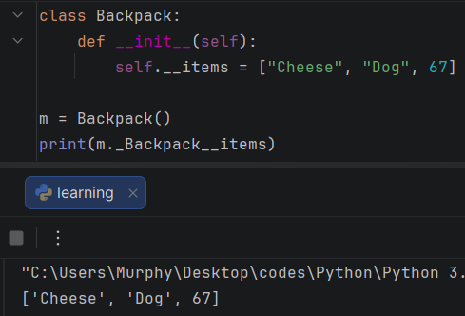
Getters and Setters
Getters and setters are members of a class particularly they’re methods.
Methods are like functions associated to a specific object or a class, they’re like the functionality that the object can perform.
In particular getters and setters let us get and set the value of an instance attribute.
Getters Get the Value of an attribute like their name.
Setters Set the value of an attribute.
Both of them help us protect the attributes by providing an indirect way to access them and modify them, so they serve as intermediaries.
Getter Example:
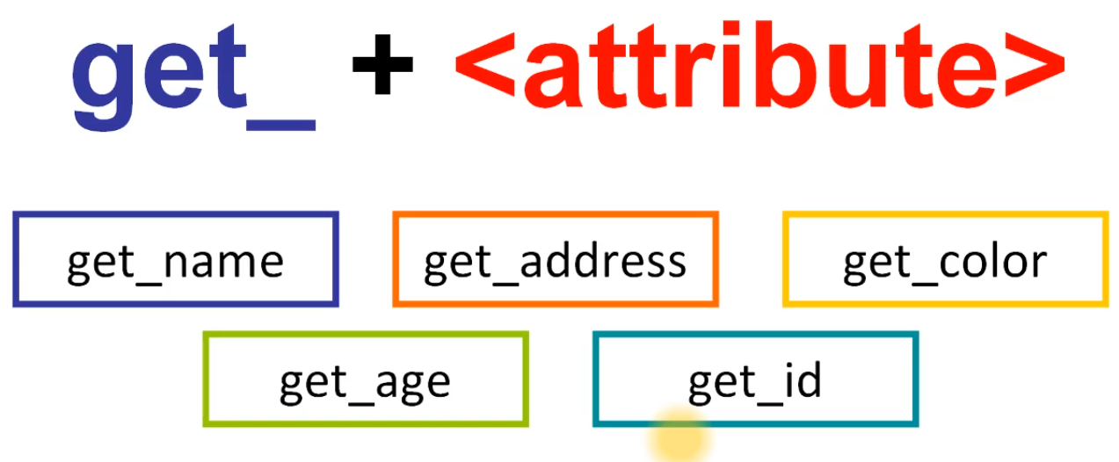

How to access an attribute using Getters?
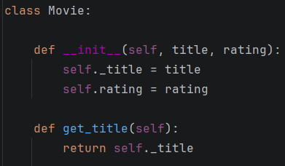
We assigned the attribute title into a Non-Public attribute and we wrote the def keyword followed by get followed by the name of the attribute: get_title.
After that we type return self._title we’re getting the value of the attribute through intermediary.
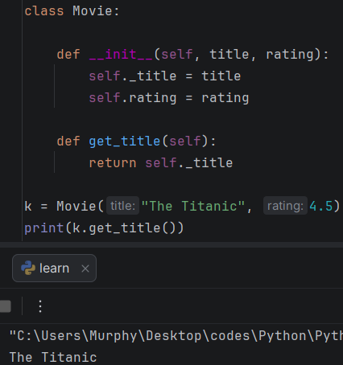
To access the attribute, we just need to call the getter and for that we use the dot ( . ) notation.
First, we write the name of the variable that holds or references the object then we write a dot followed by the name of getter which is get underscore and the name of attribute. Example:
My_movie = Movie(“The Titanic”, 4.5)
print(My_move.get_title())
Setters
Setters are basically methods, that we can call to set the value of an instance attribute, and what are the advantages of defining a setter instead of changing the value directly?
Well, that with setters we can validate the new value before actually assigning it to the attribute. So, we can check if the value is appropriate for the attribute before we actually make the update, and we can avoid making invalid updates.
Setters following this naming convention: set_ + <attribute name>
We write the word set to specify that this is a setter, followed by an underscore and then the name of the attribute.
Example:
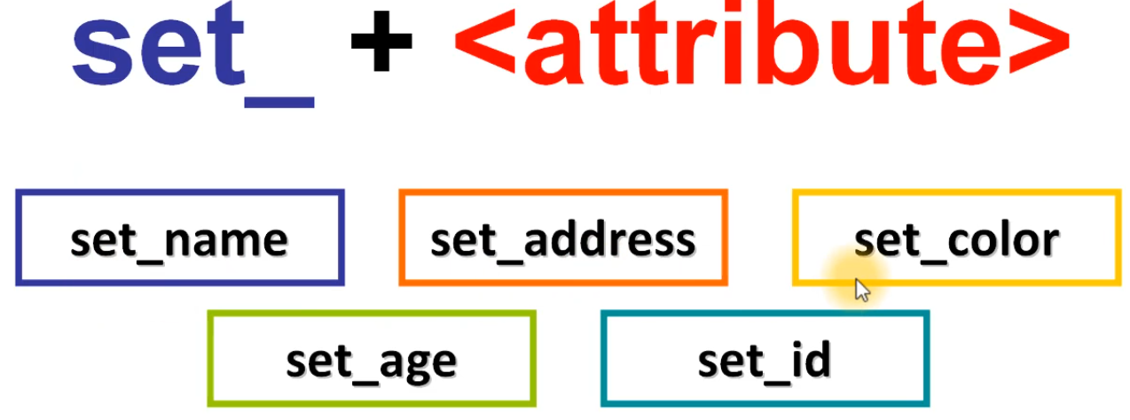
Here’s how to set a new name for a dog instance using setters:
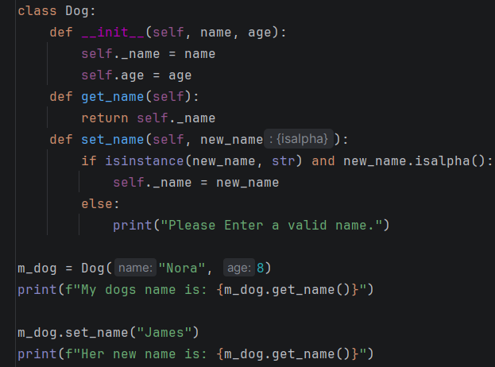This line of code: if isinstance(new_name, str) and new_name.isalpha():
Checks if the name is an instance of the class string of the type string and also checking if the name is alphabetical.
Using Getters and Setters
class Circle:
def __init__(self, radius):
self._radius = radius
def get_radius(self):
return self._radius
def set_radius(self, new_radius):
if isinstance(new_radius, float) and new_radius > 0:
self._radius = new_radius
else:
print("Invalid Radius")
m = Circle(5.2)
print(m.get_radius())
print()
m.set_radius(15.6)
print(m.get_radius())
print(type(m.get_radius()))
Output:
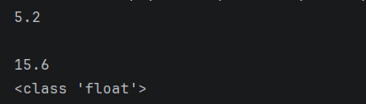
Properties
We can define a property in class using property() function, we just need to specify the getter and the setter that we want to assign for that particular property.
Example: property( <getter>, <setter> )
And assign the result or the object returned to a particular variable right here, which will be the property name.
To solve this problem, we’re going to the next in our code:

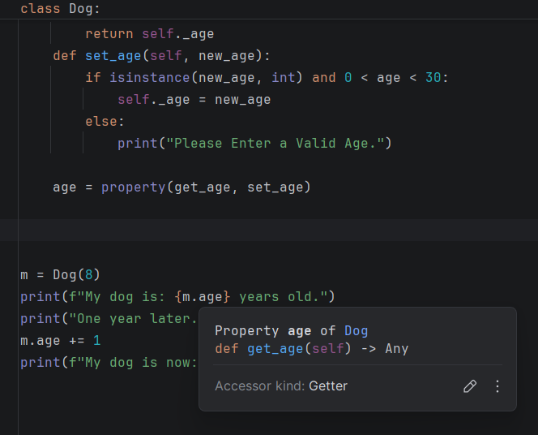
If we hover over the {m.age} we can see that it got the accessor of kind Getter.
We can access and modify the attribute with the same syntax, but now we have getter and setter acting as intermediaries.
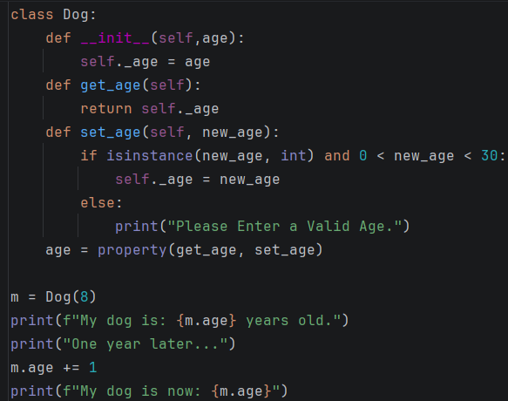
Now everything is working correctly, when we define a property in python, we can use the same syntax to access and modify the attributes. The getter and the setter will be called behind the scenes for their corresponding operation.
The @property Decorator
What is a decorator?
A decorator is basically a function that takes a function as an argument and extends its behavior without explicitly modifying it. It’s sort of like decorating another function by extending its behavior, but it doesn’t explicitly modify the function it just adds some extra flavor or functionality to the function.
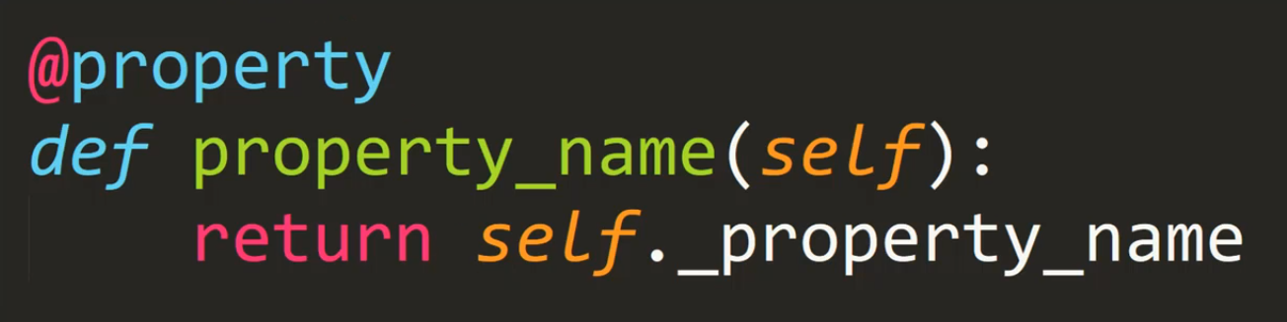
This is basically how you can define a getter using @property.
Example:
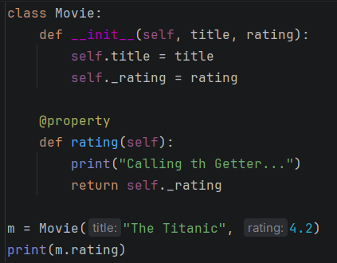

We can also define a setter with the @property decorator like this:
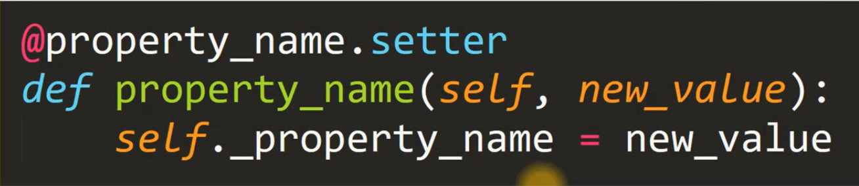
We just need to write @ followed by the name of the property that we used, the property that we created with a getter (which was rating), then we use that name, we write a dot ( . ) and then the word setter, this tells the program that this is the setter for this particular property and then we’ll use the same syntax we typically used to write a setter.
Example:
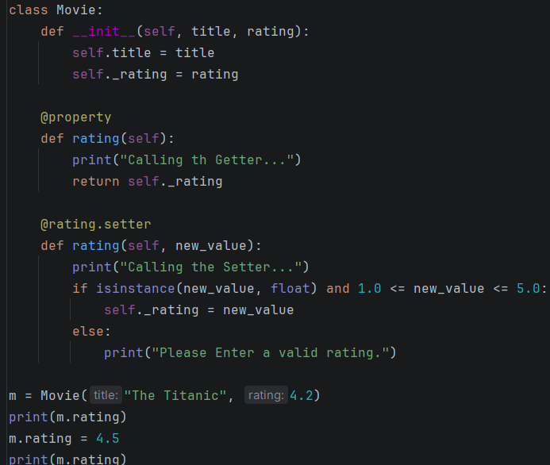
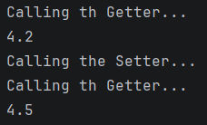
Methods
Methods are fundamental building blocks of the classes that we write in Object Oriented Programming.
We can define a method as a function that is associated to an object of the class or to the class itself.
The methods defined in class will determine the behavior of the object that are created from the class and how they can interact with their state and with other objects.
Do you remember a few sections ago we mentioned that a class defines the state and the behavior of an object. Well, in this section by covering methods, we will be learning how to define the behavior of the object, because so far, we have been focusing on the state, the attributes of an object.
There are three main types of methods:
- Instance Methods
- Class Methods
- Static Methods
Instance Methods
Instance Methods in particular are methods that belong to a specific object, because they have access to the state of the object that is calling them.
And how do these methods get access to the internal state of an object? Well, through itself (self) through this parameter that we’ve been writing so far as the first parameter in every single method that we’ve defined in our classes, like __init__(self), getters and setters.
Remember that self refers to the object or the instance, well in this case of a method it refers to the instance that is calling the method that is asking to execute its functionality.
Calling a method is very similar to calling a function, because we’re asking the program to run its functionality or execute its lines of code.
Naming Convention also applies to Methods. The method name must be in small letters and also non-public method applies to methods here you just need to put a leading underscore before the method name. for example: (_method_name) – Private Method or Non-Public Method, this naming convention is called Snake Case.

Code Example:

